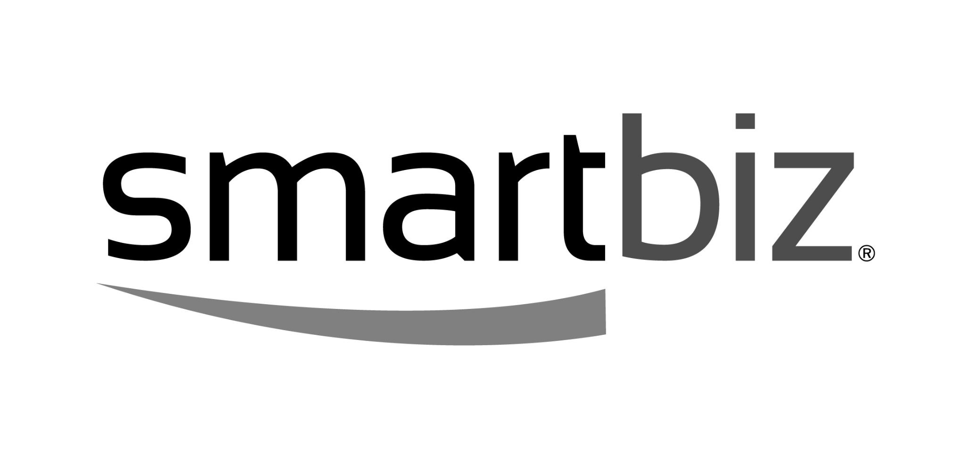

Long - About SmartBiz:

SmartBiz is the leading AI-powered small business financing platform equipping entrepreneurs with access to the right capital at the right time. To date, SmartBiz has connected borrowers with more than $9 billion in financing while increasing efficiency for its network of banks and trusted lending partners. More than 230,000 entrepreneurs have utilized SmartBiz to access the funding they need to grow, with 60% of loans made to minority, women, or veteran-owned businesses.

SmartBiz was named the Top Small Business Lending Platform by LendIt Fintech® in 2022 for excellence in keeping the economy running through successful loan performance, volume, growth, product diversity, and innovation. Founded in 2009 and headquartered in San Francisco and Austin, SmartBiz is backed by Venrock, Investor Growth Capital, First Round Capital, Baseline Ventures, and Uncork Capital. Learn more about smartbizloans.com.

Short - About SmartBiz:

SmartBiz is the leading AI-powered small business financing platform equipping entrepreneurs with access to the right capital at the right time. More than 230,000 entrepreneurs have utilized SmartBiz to access the funding they need to grow, with 60% of loans made to minority, women, or veteran-owned businesses. SmartBiz was named the Top Small Business Lending Platform by LendIt Fintech® in 2022 for excellence in keeping the economy running through successful loan performance, volume, growth, product diversity, and innovation. Learn more about smartbizloans.com.

